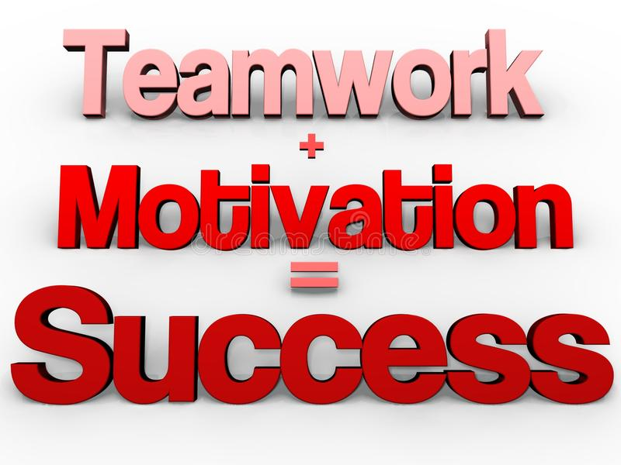
SUNDAY FUNDAY
Perx Sunday school

SHOW US WHAT YOU’RE MADE OF, HOW MOTIVATED ARE YOU.
CLOSE MORE DEALS MORE THAN ANYONE ELSE TODAY AND YOU COULD BE A WINNER.
OR WORK TO TOGETHER AS A TEAM MOTIVATE EACH OTHER AND SHARE THE SPOILS
YOU
DECIDE.

T’s &C’s
HAVE LOADS OF FUN TAKE PICTURES AND SEND WITH YOUR REPORT.
If you decide to purchase refreshments for your team please ensure you don’t buy anything that will make your store smell like a TAKE OUT venue.

If you have an outright winner, they win 50% of your stores allocated amount and the other 50% you use to purchase refreshments for the team.
Please ensure you keep all SLIPS and hand in to your FM on Monday morning, should you fail to do so you will be liable for all expenses.

Motivating Your Team 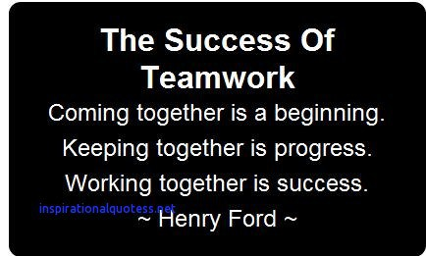
The staff of a business are the most important and most valuable resource they have. In order to retain employees and get the most out of them, they have to be motivated and engaged in what they do on a day to day basis. So, what is motivation? Job satisfaction, meaning and drive for outstanding performance.
There are common denominators that prove to motivate us such as; wages, good working conditions, team spirit and good relationship with your manager. However, in this modern world we live in today, these factors are more frequently being met and losing their capability to motivate us. We now pursue other motivational factors such as power and control, growth opportunities, challenging and difficult work and recognition for exceeding expectations in the workplace. Each member of a team has to be motivated for the entire team to be motivated. Every individual is driven by different stimulus, meaning the same one technique cannot be used successfully for all employees. As a manager you have to understand motivational variances and establish individual drivers. A One to One meeting can be a good opportunity to find this out.

Moreover, setting clear and precise team goals allows all members to inclusively work together towards a collective shared vision. Contributing to an end product motivates an employee to produce good work as they feel like they have a purpose and responsibility. A SMART approach helps produce effective goals. (Specific-Measurable-Achievable-Realistic-Time based) Try and avoid boring work and getting into too much of a routine in the workplace you manage. No matter how self-motivated one is, if the work is ‘same old - same old’, boring and poorly organized, it is hard to stay motivated. Provide a working environment employees can excel in and constantly develop new skills and abilities to grow within the department. The store is normally a fast-paced work environment where as soon as one target is met, all eyes change focus to the next set objective. Why not celebrate a success? A richly-deserved pat on the back contributes a feel-good factor. As they say ‘The journey of a Thousand Miles Begins with One step’ – So why not acknowledge each step of success.
Furthermore, a healthy competition reward could be introduced to enhance motivation if necessary, such as voting for ‘Employee of the Month’. As a manager you are in such a powerful and meaningful position, that frequently praising and acknowledging team members’ good work can go a long way. Whether this is informal praise, public recognition in front of co-workers or via email – it doesn’t take much to give employees the credit they deserve. It makes them feel valued and appreciated, which in turn will motivate them to work harder.

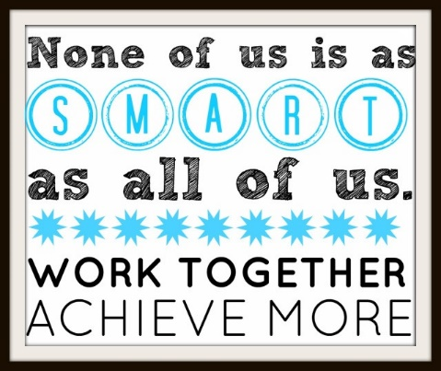

Additionally, Managing Team Expectations effectively works as a motivator as the more that is expected from them, the harder they will work. Another factor that can aid motivating your team is Avoiding Micro-Management as a manager. Constantly hovering over team members shoulders won’t by any chance motivate them to produce quality work, but trusting them to do the job, will. Giving members a sense of authority and liberty to work will naturally motivate them to do well as they can uniquely contribute to the organization.
Subsequently this boosts self-esteem, morale, confidence and productivity. A win-win for you, them and the business.
In summary, to motivate a team, each team member has to be motivated. Apply incentives and opportunities uniquely tailored to them. Work design has a strong impact on performance. Teams will only reach full potential if their manager is a good motivator. Consistently give effective appraisal all the time.
https://drive.google.com/open?id=1BQKEzvc6sKjSU-kYqsed7uPJeDySd1Cn&authuser=0
https://www.youtube.com/watch?v=jop2I5u2F3U
https://www.youtube.com/watch?v=kxJ3-3K-4NE

ASSESSMENT
https://docs.google.com/forms/d/e/1FAIpQLSf88_q-6RbpqSXSg73Cm9CjYJ8r4Jqyx-WZrty05e1uLQ9p1Q/viewform?usp=sf_link

