TEST LINK:
https://docs.google.com/forms/d/e/1FAIpQLSdC7y8n0mH1x8y3TlHuk7Ek58KjrTvltezGaLd4nANdY3Yx-g/viewform?usp=sf_link

Telkom August DOM

What’s the BIG deal?
With the August BIG Deal, you get a SmartBroadband Wireless package (20GB Anytime data + 20GB Night Surfer data + Double Your Data) at R369pm plus a free Huawei B315 LTE Wi-Fi Router. Whether you’re sharing the latest in entertainment with your friends and family, or you’re a business owner seeking digital power, the August BIG Deal is just for you.
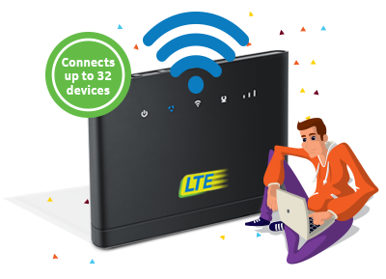

About the device
Winter’s still here and we know you’re looking for the hottest device on offer. The Huawei B315 LTE Wi-Fi Router is the perfect companion for you, keeping you connected to the net. Connect up to 32 devices wirelessly, with strong Wi-Fi coverage, and a Hi-Speed USB 2.0 port supporting HDDs, USBs, network storage devices and printers.

About the connectivity
The Huawei B315 LTE Wi-Fi Router connects using a 4G SIM card, making sure your speeds are never less than super-duper fast. Your 4G SIM can be used on multiple devices too, from your phone all the way to your laptop.
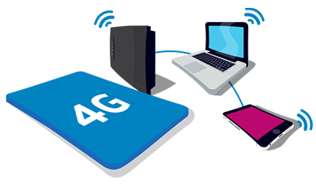

Explaining the data plan
We heard you want more data. The August SmartBroadband Wireless package gives you just that, with 40GB of Anytime data and 40GB of Night Surfer data*. That’s a whopping 80GB of data altogether! You like downloading? That’s 160 movies, 456 TV episodes or 32 000 songs worth of downloads! With your Huawei B315 LTE Wi-Fi Router, you can share data and save costs.

August Big Deal 2018

With Huawei B315 LTE Router
R369^{.00}
PM x 24

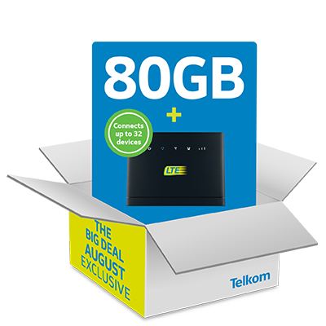

The August Big Deal on SmartBroadband Wireless
- 40GB Anytime data
- 40GB Night Surfer data
- FREE Huawei B315 LTE Wi-Fi Router

August Big Deal 2018
With Huawei B315 LTE Router
Terms and Conditions for Double Data SmartBroadband Wireless
1. The Deal is SmartBroadband Wireless 20GB which is a double data offer, which includes 40GB Telkom anytime data per month (available on Telkom network which is non-roaming) and 40GB night surfer data per month also on Telkom coverage.
2. Night Surfer Data shall be valid between 12am – 7am.
3. Subscribers who sign up for the double data SmartBroadband Wireless 20GB each month shall receive the double data allocation for the duration of the 24-month contract and after 24 months the data allocation shall revert to the single data allocation for both anytime data and night surfer.
4. The double data SmartBroadband Wireless is a promotion and Telkom reserve the right to retract the offer at any time and with no prior warning to customers.
5. Telkom reserve the right to throttle and/or shape the traffic of the Double Data SmartBroadband Wireless products in the network peak times between 6pm and 11pm daily.
6. The Telkom’s Double Data SmartBroadband Wireless offers shall be available on a 24-month contract that includes an LTE Wi-Fi router.
7. The SmartBroadband Wireless subscribers who deplete their inclusive allocated data, have an option to Topup with LTE/LTE-A Once-off data bundles, which expires 31days from the date of activation.
8. SmartBroadband Wireless post-paid customer who top-up/purchases the Once-Off LTE/LTE-A bundles (which expired in 31 days) in the middle of the month, if not completely utilized the remainder of the data bundle will carry over into the next month and expire on the set expiry date.
9. SmartBroadband Wireless post-paid customer at the beginning of the new month, shall be allocated the inclusive data which is anytime and night surfer. The inclusive allocated data will always be the primary bundle that will be consumed first and there-after the remainder of the data bundle carried over of LTE/LTEA Once-Off bundle if applicable.
10. Telkom Standard terms and conditions apply (full details on www.telkom.co.za/terms).
11. Telkom reserves the right to amend these offerings and terms and conditions from time to time. Telkom will place the amended terms and conditions on Telkom’s website at the following link: http://www.telkom.co.za; which will be deemed incorporated into the Agreement and bind the Consumer from the date that the amendment was listed on the abovementioned site.
12. RICA shall apply for the double data SmartBroadband Wireless 20GB.
13. Subscription to Telkom’s SmartBroadband Wireless service is subject to the availability of its LTE network coverage within the specified location and the subscriber will not be able to roam on MTN’s 3G network. A Sales agent will be able to assist you with checking if your address is in coverage Or alternatively you can do it online at http://www.telkom.co.za/coverage/ or send an SMS with your address to 43482
14. The SmartBroadband Wireless service is provided as a fixed wireless broadband service for use in a fixed location and should a subscriber relocate, Telkom cannot guarantee and be held liable for lack of network coverage, reliability and throughput outside its specified LTE coverage areas
15. Should a subscriber use his SmartBroadband Wireless service for mobility purposes Telkom shall not be liable for lack of LTE coverage or throughput outside of its LTE coverage areas?
16. 3G failover to Telkom Mobile’s 3G network only will be supported on the SmartBroadband Wireless service.
17. Telkom shall endeavour to ensure that LTE coverage is available where Telkom stipulates it has LTE coverage. Telkom shall not, however, be held responsible for customers’ failure to access the Internet in areas that are not eligible for LTE.
18. A compatible device is required to use Telkom’s LTE services. The maximum speed that can be experienced by the subscriber is dependent on the speed specification of the device
19. Telkom’s LTE network currently supports voice calls; however, a subscriber will be required to contact Support on 081 180 through any means of communication available to them to request that the voice capability be enabled on their service
20. A flat rate of R 2.75 on per second billing basis will apply for any voice call on SmartBroadband Wireless service, with exception of emergency services (10111, 10177 and 112) and Telkom helpdesk 081 180 which are free from a Telkom Mobile SIM card.
21. SMS is enabled for normal usage, notification and balance enquiry
22. SMS charge is set at 50c/SMS and MMS charge is set at 50c/MMS.
23. The out-of-bundle rate of R29c (twenty nine cents) /MB applies
24. Inclusive allocated data bundles will expire at the end of the current calendar month
25. No carry-over shall apply to the Inclusive allocated data
26. SmartBroadband Wireless subscribers shall be required to link a secondary mobile device to their plan via their My Telkom Mobile account in-order to consume the free Wi-Fi bundle which can only be consumed at a Telkom public Wi-Fi hotspot
27. Telkom’s LTE network supports downlink speeds of up to 90Mbps and uplink speeds of up to 25Mbps.
28. Telkom’s LTE network is supported on the 2300MHz TDD Radio frequency spectrum and the experience may vary depending on the wall thickness at your premises.
29. Telkom is not liable for any loss or damage to your property or equipment arising out of the provision, installation or maintenance and use of the service.
30. Telkom will not incur any liability whatsoever for any loss or damage as a result of any use, authorised or unauthorised, resulting from virus attacks, security vulnerabilities, or loss of information.
31. Prices are valid at date of print. E&OE.

