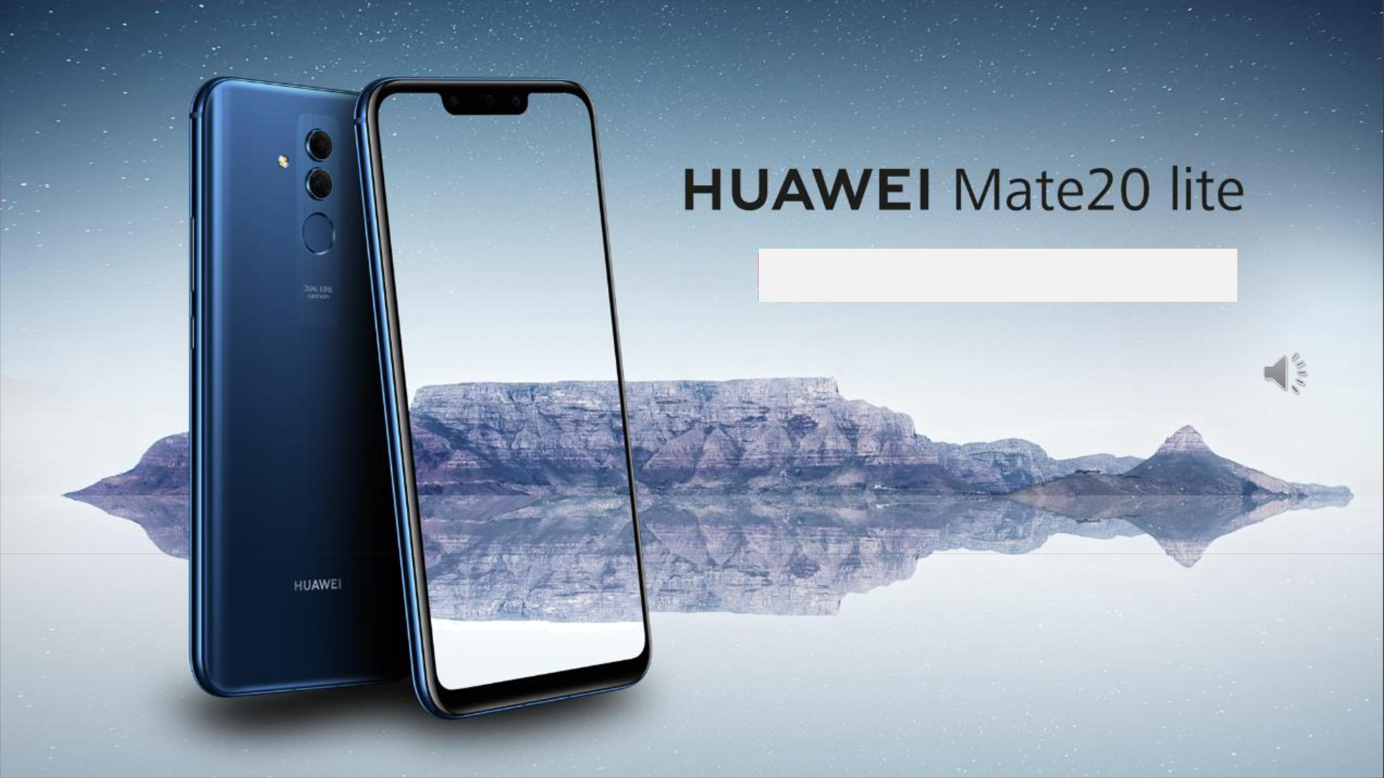

4 AI Camera Smartphone

First in the world

Launch SA 5th Oct

Test Link: https://goo.gl/forms/bVsfM2irvNpLSx5f2



HUAWEI Brand And Mate Series

When will Huawei be No1 in the world？

Mate20 lite

Mate20 lite

 | 2018 | Growth | 2019
 | (July) | (Year) | (July)
Samsung | 73 | -8% | 67
Huawei | 54 | 41% | 76
Apple | 41 | 1% | 41
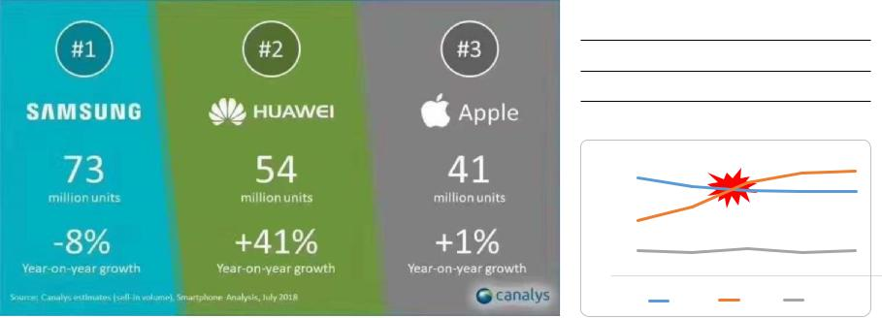

80

70

60

50

40

30
18-Jul | 19/Q2
Samsung Huawei Apple

Why Huawei is so successful（3High）

Mate20 lite
Mate20 lite

High technology investment |  |  | High innovation
HUAWEI 10.4B€ （No: 6） |  |  | HUAWEI patent 74,307 pcs
APPLE | 9.5B€ （No: 7） |  | HUAWEI patent 74,307 pcs
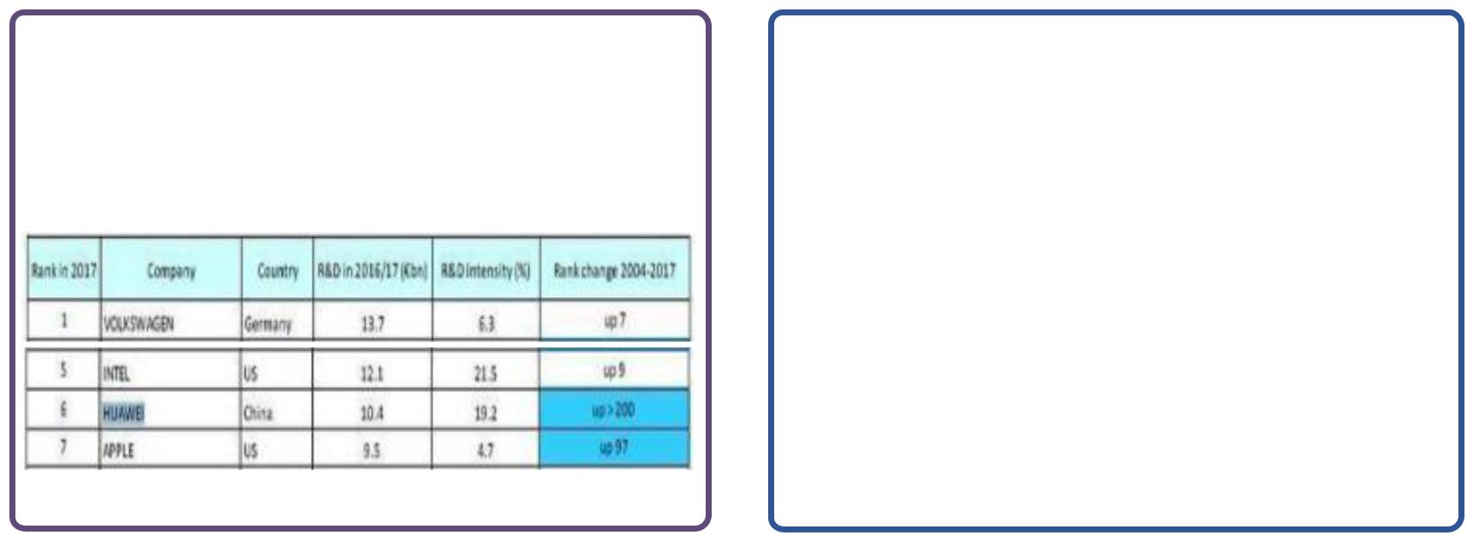

$ 62.5BN – in past 10 years 79,000 – 45% of Total employees 36 – Joint innovation centers 16 – R&D centers

2016~2017 years

High quality
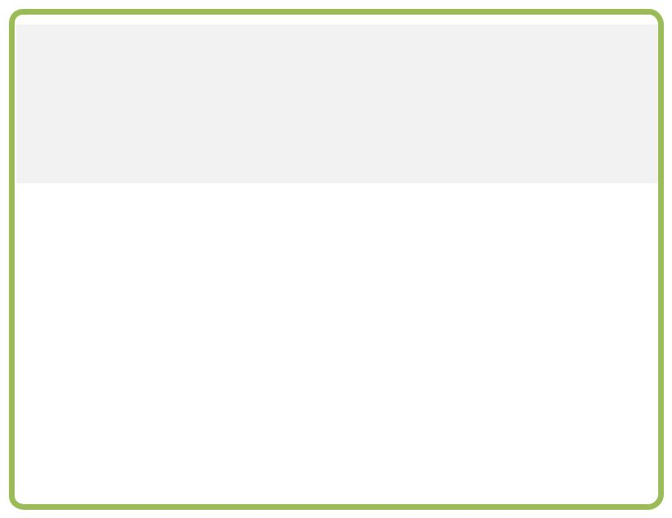

Crazy quality standards

Test environment
Huawei 90℃（general 60 ℃ ）
** per +10%，failure +100%

The power switch test
Huawei 1M times（general 0.2M）

- Product quality: If you make 1 micron mistake，you will change the world.（e.g. **7）

HUAWEI Mate Series Family

Mate20 lite
Mate20 lite

Mate RS Mate10/? Pro Mate20 lite NEW
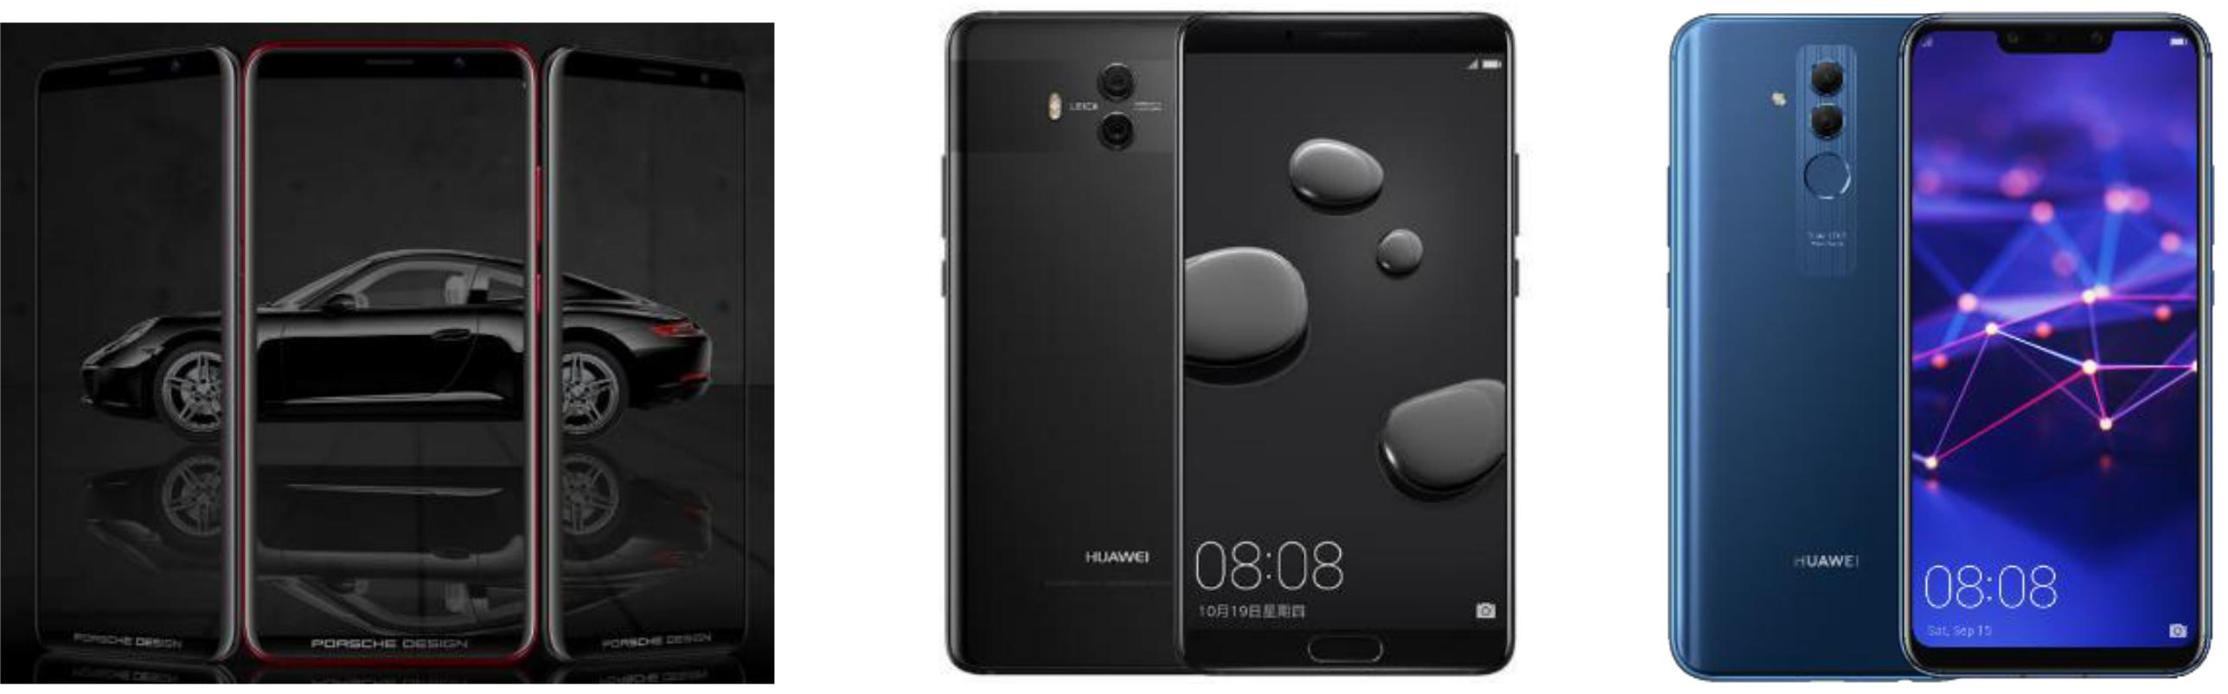

Pinnacle design Future technology exceed expectations

Dynamic aesthetics Early enjoyment Flagship phone

Mate20 lite Sales Point (consultant 1time)

Mate20 lite Key Sales points

Mate20 lite
Mate20 lite

Mate20lite ：4 AI Camera Smartphone，First in the world

---- selfie king（photography）
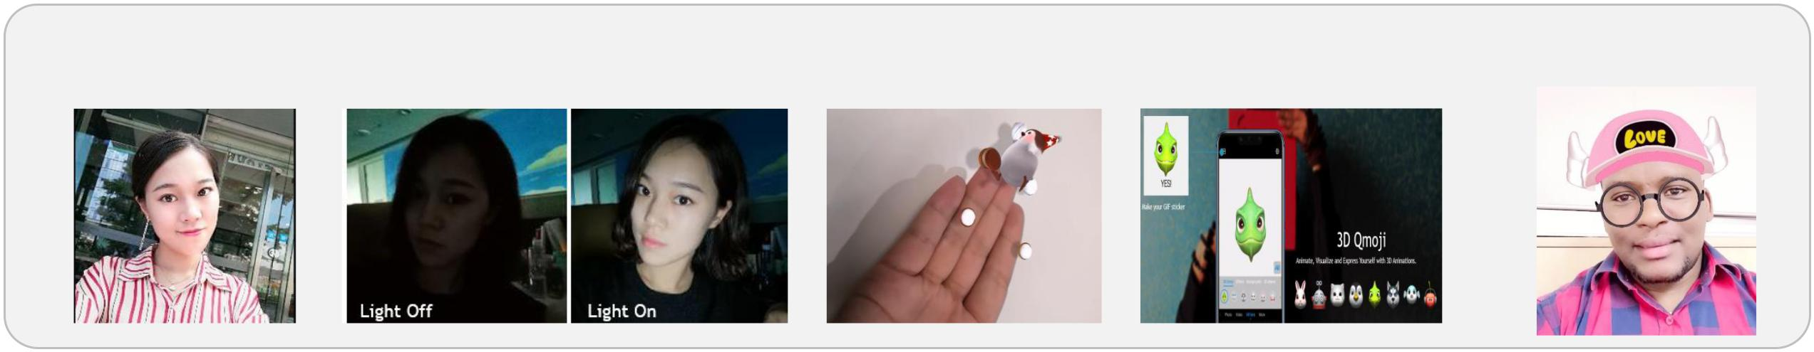

➢ selfie king ➢ Low light solution ➢ 3D objects ➢ 3D Qmoji ➢ Effects

AI Scenery Recognition: front 8/ back22；Piexl：front 24MP+2MP / back 20MP+2MP

More reasons to have mate20lite

Mate20 lite

Mate20 lite

Attention: PLS Identify customer key needs in life , before introducing the device.

Find Beautiful | Technology fans | Business | Entertainment
4 AI Camera | AI & GPU turbo | Security & battery | Speed & Screen
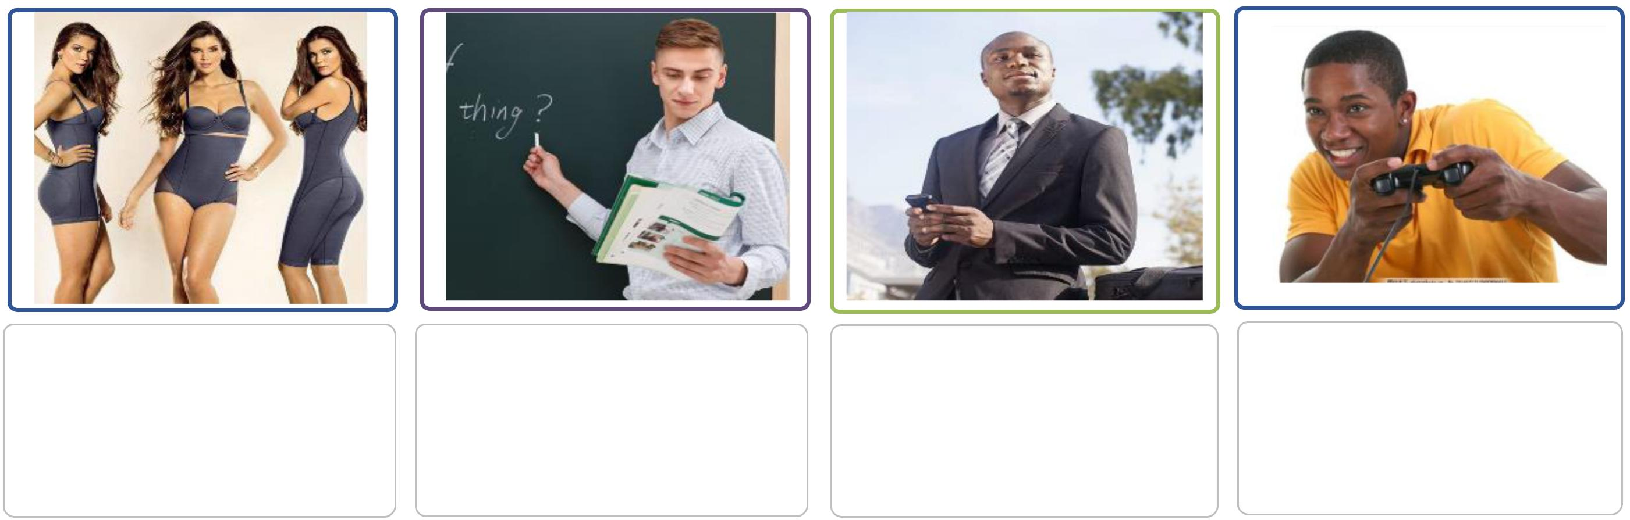

➢ Selfie king | ➢ AI CPU(Kirin 710 ) | ➢ 360° Face Unlock
➢ Low light solution | ➢ GPU turbo | ➢ APP lock+Privatesapce
➢ 3D objects | ➢ AI Camera | ➢ Device Link to screen
➢ 3D Qmuji |  | ➢ Easy copy
➢ Effects |  | ➢ 3750mAh big bettery
➢ Slow motion |  | ➢ Fast charge

- GPU TRUBO
- Big Screen 6.3”

- AI game suite

- Music(Histen 5.0)

Mate20 lite VS S8

Mate20 lite
Mate20 lite

More better than S9，Mate20 lite selfie |  |  | VS Note9，what is happen？
 |  | Mate20lite |  | Samsung S8
 |  | 4 AI cameras . |  | 2 Normal cameras
 | Cameras | Front : 24MP + 2MP |  | Front : 8MP
 |  | Rear : 20MP + 2MP |  | Rear : 12MP Dual
 | Display | 6.3” |  | 5.3”
 | Battery | 3750mAh |  | 3000 mAh
 | Memory | 64 GB+4 GB RAM |  | 64 GB+4 GB RAM
 | GPU | GPU Turbo |  | No GPU enhancers.
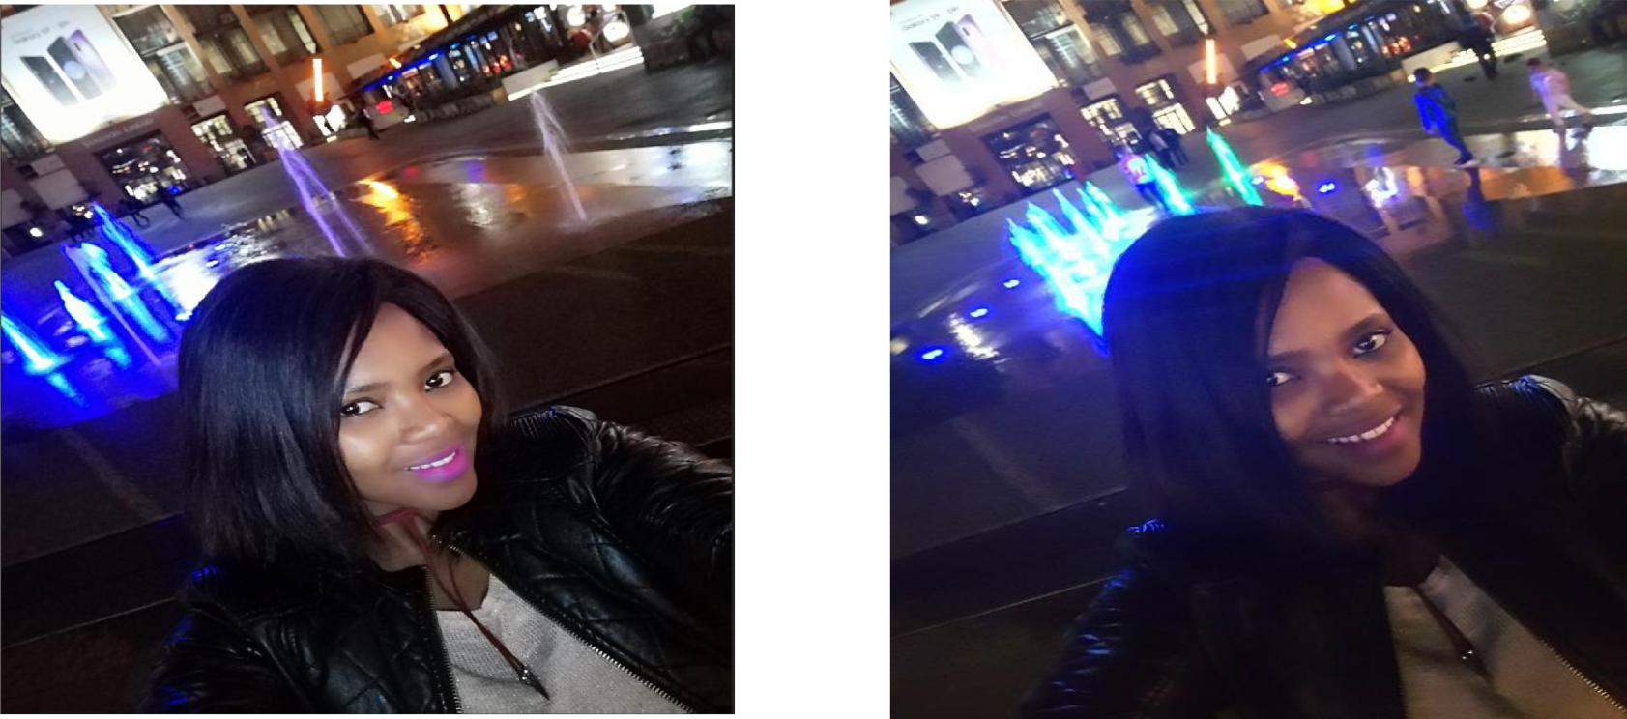

Show cunsumer（consultant 2time training）

Find beautiful – 4 AI Camera（photography master）

Mate20 lite
Mate20 lite

AI Selfie Experience -- show you are beautiful | 3D Qmoji | Slow motion
Low Light Solution
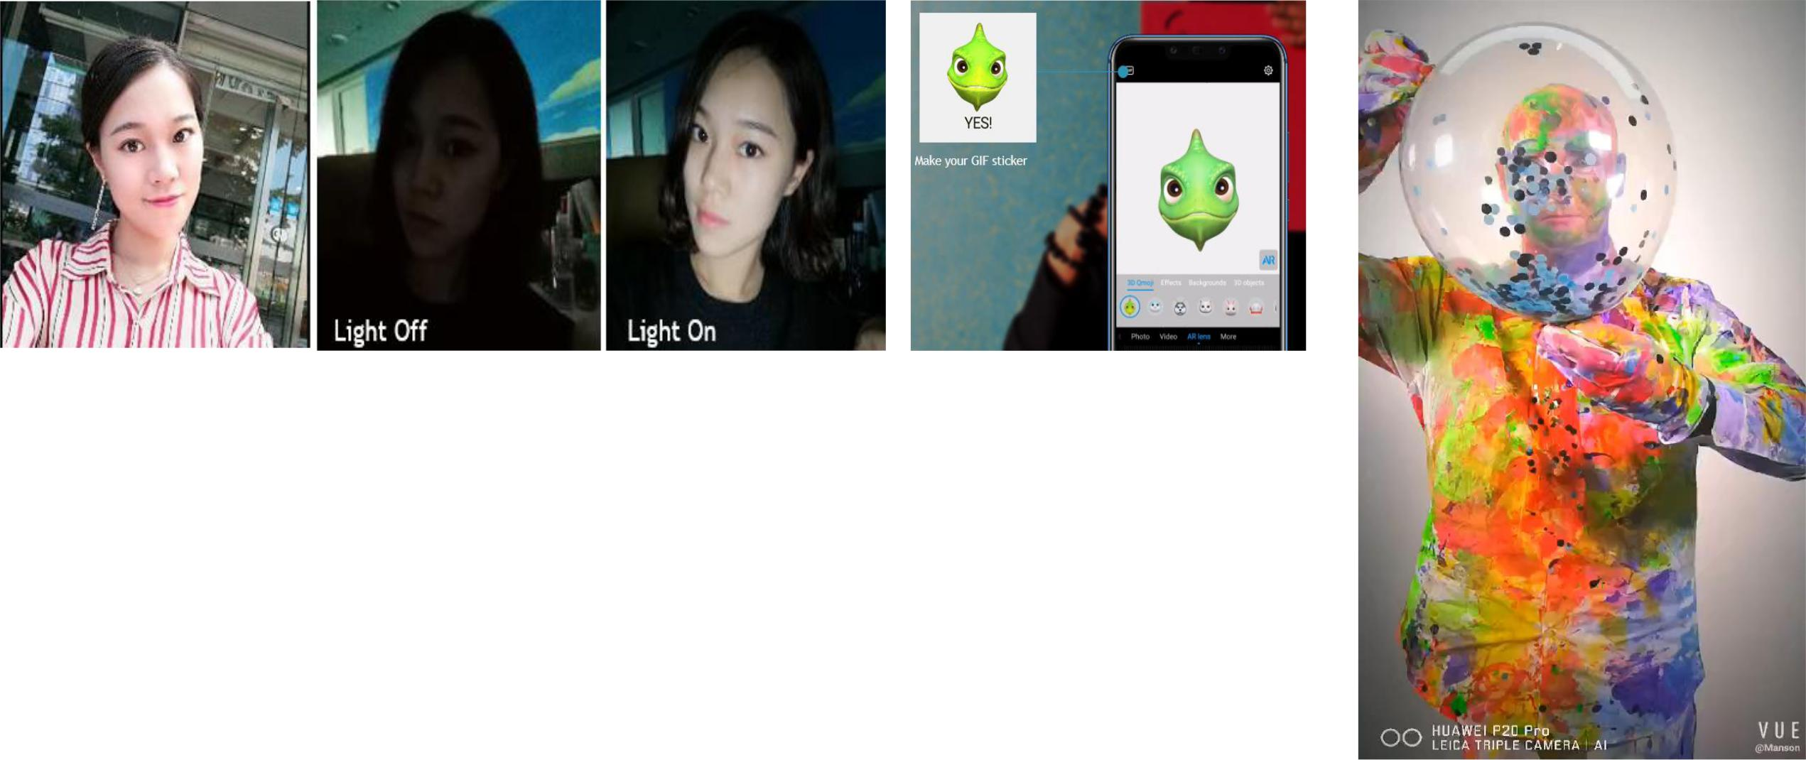

3D objects Effects

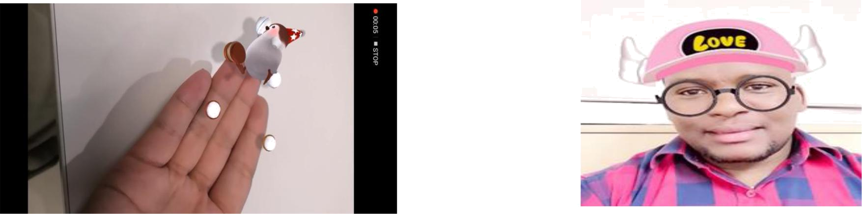

AI Scenery Recognition: front 8/ back22；Piexl：front 24MP+2MP / back 20MP+2MP

Technology fans – AI & GPU turbo


Mate20 lite
Mate20 lite

GPU Turbo

➢What is AI，What can AI do? | ➢What is GPU Turbo? Do you know AMG?

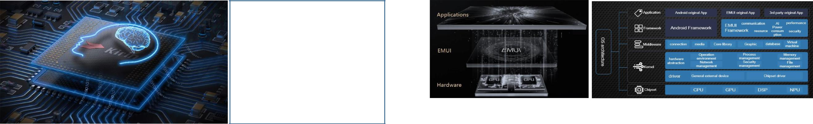
New Generation
Kirin 710

with AI Capability

4×Cortex A73 2.2GHz + 4×Cortex A53 1.7GHz

➢What's the GPU Turbo benefit?

How did Huawei do it?

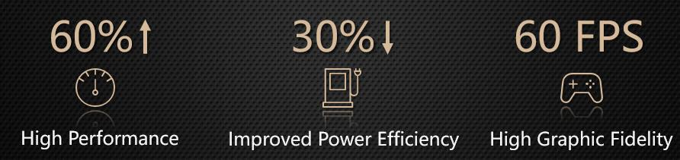
- What's the AI benefit?

4 AI camera -- Makes you instantly a master photographer

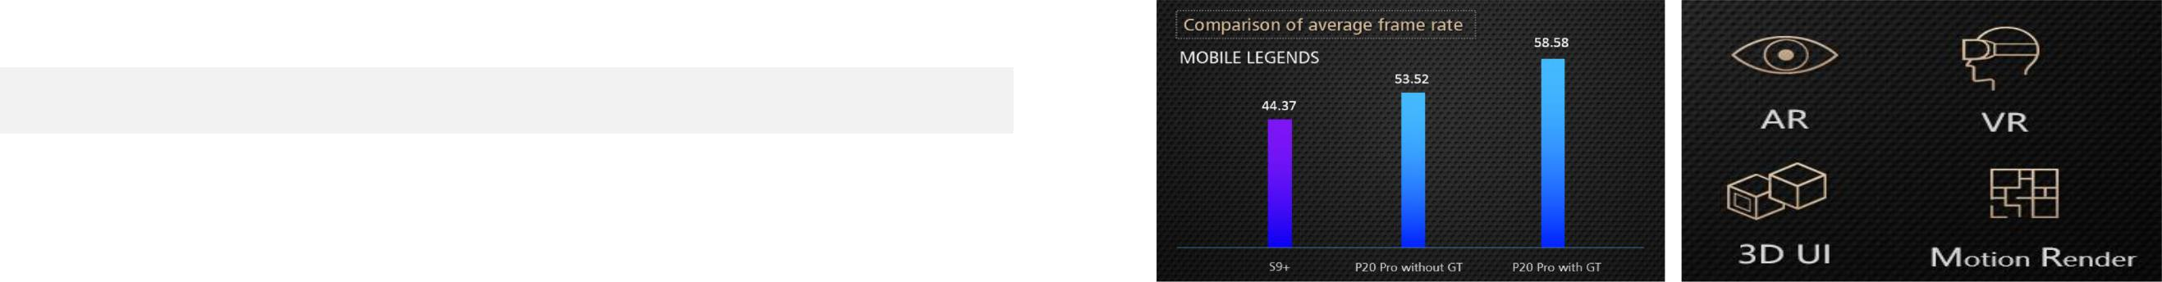

3D Objects - Enjoy real-time 3D animation effects

AR life experience - Explore the future world with you

Business – Security & battery
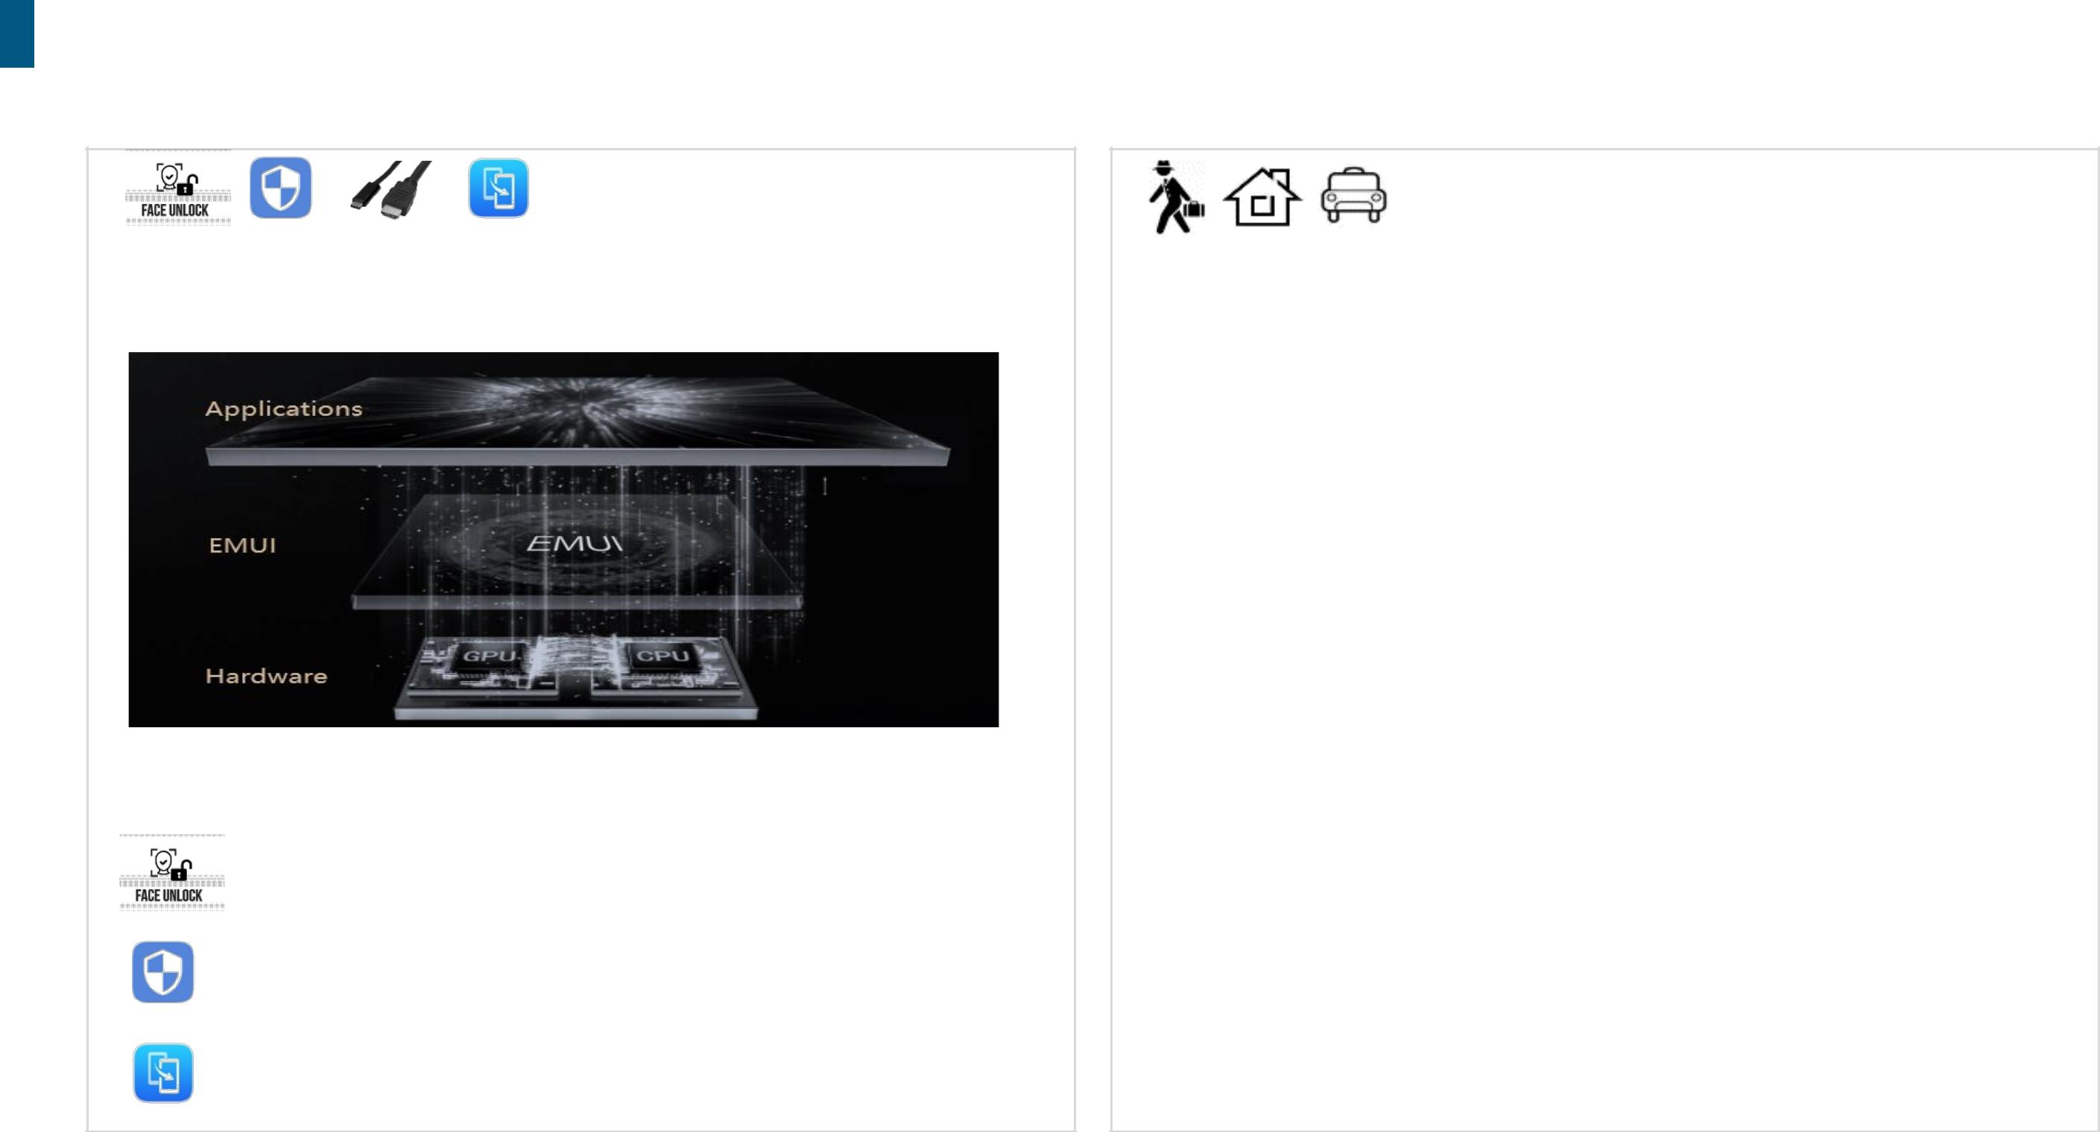
Mate20 lite
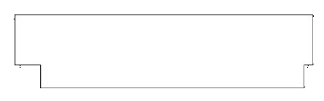

Mate20 lite

 | Huawei Fast charge Family
Huawei 3 Step Security – Easy to use | Charge anytime, anywhere. Keep the power.

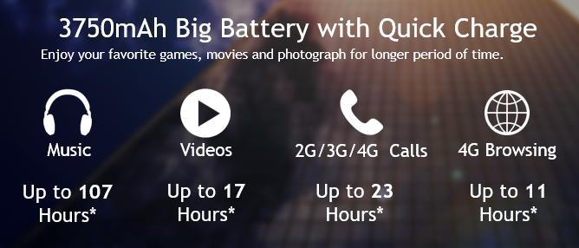

EMUI 8.2





Fast charger | Fast car charge
1Second - 360 Degree Face Unlock
1Touch - APP LOCK + Privatesapce

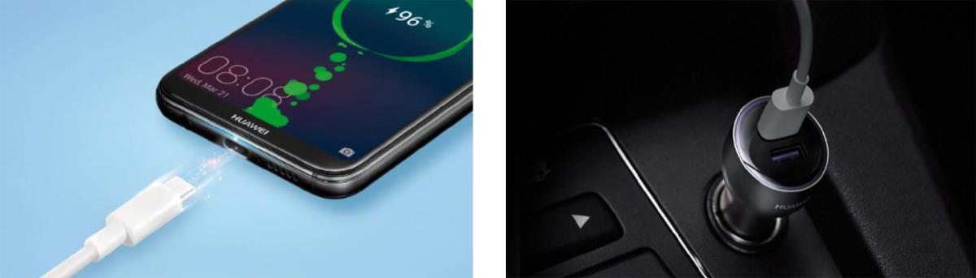

1APP: Easy copy with Huawei Phone Clone | Fast, easy home charge | Fast charge on the road

Entertainment - Speed & Screen

Mate20 lite
Mate20 lite

GPU TRUBO | Big Screen
Fast battery saving processor | Trendy design

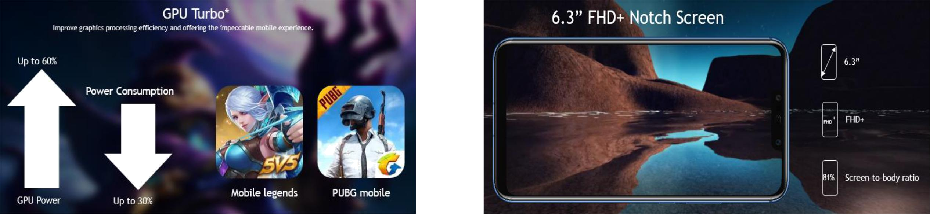

AI game suite | Music(Histen 5.0)

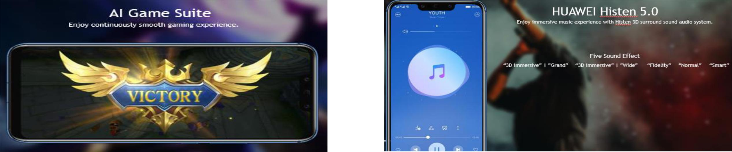

Fast battery
saving Gaming

