JULY 2018 DOM DEAL

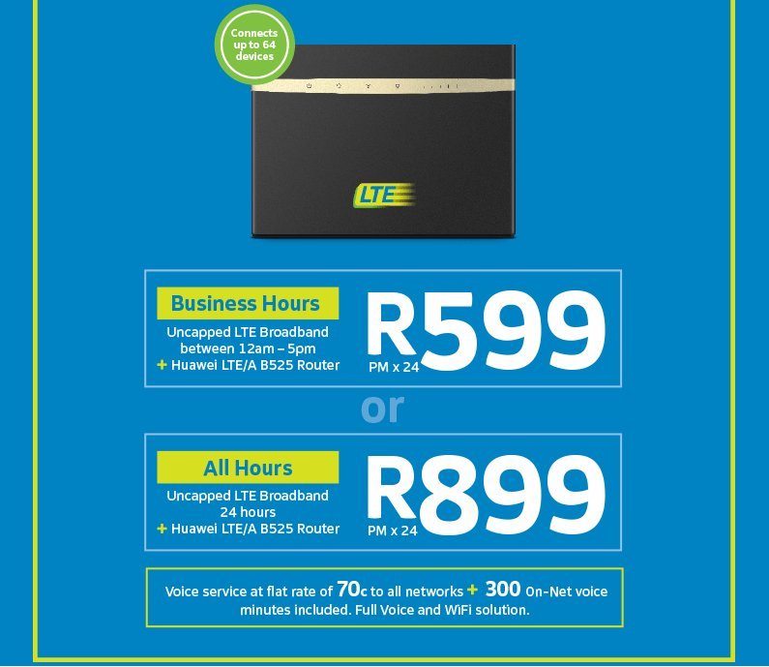

What’s the big deal?
This July you can get uncapped LTE internet for your home or business. Choose between either Uncapped LTE Business Hours at R599pm x 24, or Uncapped LTE All Hours at R899pm x 24. Business hours are from 12am to 5pm. Everyone can connect with the Huawei B525 LTE Router as it can connect up to 64 wireless devices, and it is free with either deal!

July Big Deal 2018 Uncapped LTE Business Hours

with Huawei B525 Router

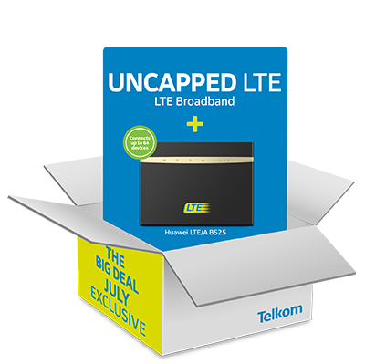

Uncapped LTE Business Hours
- Operating Hours : 12AM – 05:00pm (7 days a week)
- 300 On-Net Minutes on all Telkom Mobile and Telkom fixed lines pm
- Uncapped data and voice to All Networks (FUP and OOB rates applies)

More about the device
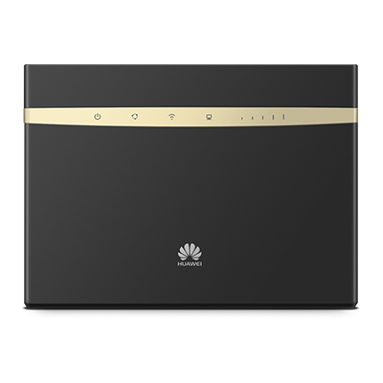
The Huawei B525 Router offers super-fast connecting, either via wireless or LAN. It also comes with a RJ11 port for voice, perfect for an all-round communication and connection solution!

Device Features
- Connect up to 64 wireless devices
- Download speed up to 300Mbps and upload speed up to 50mbps
- RJ11 port for voice

July Big Deal 2018 Uncapped LTE All Hours

with Huawei B525 Router

- Uncapped LTE All Hours

Uncapped LTE All Hours
- 300 On-Net Minutes on all Telkom Mobile and Telkom fixed lines pm
- Uncapped data and voice to All Networks (FUP and OOB rates applies)

As always remember that when you are selling a product or service, you are selling the benefits, not the product or service itself.
To sell a product you need to remove yourself from the equation. Selling is largely a process and must be adapted and modified according to circumstances.
You need to understand the product and its benefits. What you need to do to get to this place is about study and practice. Study the product or service and what it brings to customers, the value it brings, and understand those benefits in-depth.
Next, practice your pitch on the product, using all the best PR techniques to get to a point where you can sell convincingly. In other words, put a positive spin on the product’s key attributes, and be able to respond positively (or counter) any negatives and objections.
There is a lot of pressure on us sell and push the DOM deals every month and based on last month’s performance we know that we can. So let’s push hard and get it done.
GOOD LUCK

Please note the below T’s and C’s and ensure that you understand and know how to explain to clients.
July 2018 Big Deal Terms and Conditions
July 2018 Big Deal Terms and Conditions: Smart Broadband Wireless Uncapped All Hours & Business Hours.
Standard Fair Usage Policy (FUP) applies across both the SmartBroadband Wireless Uncapped All Hours & Business Hours products whereby on the 1st of each month customers will receive 150 GB of data that allows for an up to 10Mbps speed and once the 150GB is depleted then an additional 50GB of data is provided at an up to 4Mbps speed and once the 50GB/4Mbps bundle has been depleted the service then provides uncapped data at an up to 2Mbps speed for the remainder of the month. Peer to peer and NNTP type protocols are further speed restricted.
The SmartBroadband Wireless All Hours & Business Hours products utilize a wireless radio network to provide Broadband service and as such no speeds are guaranteed and service is provided in a strict best effort manner. Factors such as those in point 40 above prevail.
The SmartBroadband Wireless Uncapped Business Hours product will provide service strictly between Midnight – 5:00 pm 7 days per week. The service will not operate from 5:01pm to 23:59:59am, the LTE/LTE-A Once-Off data bundles can be purchased to access service beyond the standard times of operation. LTE/LTE-A Once- Off bundles purchased to provide service and be utilized from 5:01pm to 23:59:59 am to allow internet access.

