A3 – Introduction to Sales Level 1
"Customer service is the ability to provide a service or product in the way that it has been promised" Customer service is about treating others as you would like to be treated yourself Customer service is an organization's ability to supply their customers' wants and needs" Customer Service is a phrase that is used to describe the process of taking care of our customers in a positive manner" Customer Service is any contact between a customer and you, that causes a negative or positive perception by a customer" Customer service is a process for providing competitive advantage and adding benefits in order to maximize the total value to the customer" Customer Service is the commitment to providing value added services to external and internal customers, including attitude knowledge, technical support and quality of service in a timely manner" Customer service is a proactive attitude that can be summed up as: I care and I can do

Why do customers leave or go somewhere else
1% die
3% move away
68% quit because of an attitude of indifference towards the customer by the staff.
14% are dissatisfied with the product.
9% leave because of competitive reasons.
For every customer who bothers to complain, 26 other customers remain silent.
It takes 12 positive service incidents to make up for 1 negative incident.
The average "wronged customer" will tell 8-l6 people about it.
Over 20% will tell more than 20.
1% of unhappy customers will not willingly do business with you again
70% of complaining customers will do business with you again if you resolve the complaint in their favour.
95% of complaining customers will do business with you again if you resolve the complaint instantly.
Reducing customer defections can boost profits by 25-85%.
5% say that a simple apology would have prevented them from moving to the competition.
80% of complaints received by an organization are likely to have poor communication as their root cause, either with the customer or within the organization itself.

Customer loyalty can be worth up to 10 times as much as a single purchase.

Anyone can sell.

That’s not to say it’s not going to take a lot of practice. If you’re listening properly and looking for the right cues, you can always tell if a customer is interested in what you have to say, what approach to take with them, and what exactly they’re looking for.

Get to know your customer

“Establishing trust is critical to selling,” “Once the customer feels that an agent is only after the commission and they don’t really trust your advice, they’ll instantly get turned off and get hesitant about making a purchase.”
To accomplish this, we recommend treating the customer like they are a friend. Establishing a connection with your shoppers will go a long way not just when it comes to sales, but also in terms of cultivating strong customer relationships.

“Be interested in your customers. Know their names, treat them like friends and make them feel comfortable. That way, when you tell them that this is the product or service they require (or not), they’re going to trust you.”

THE ART OF COMMUNICATING EFFECTIVELY WITH CUSTOMERS
To develop good relationship with a customer, it is important to look well-groomed and
communicate effectively and in a polite manner with the customer. This is the starting point for establishing a winning relationship with the customer.

You can establish effective relationships with customers by.

Communicating with your customers in a way which makes them feel valued and respected.

Identifying and confirming the needs and expectations of your customers.

Treating your customers courteously and helpfully even when you are working under

pressure.

Maintaining communication with your customers to ensure that they are kept informed and

reassured.

Adapting your behaviour to respond effectively to different customer behaviour.

Know your inventory inside and out

Sales agents should be “masters of their inventory,” Having adequate product knowledge allows you to suggest items quickly and effectively.
For instance, if a customer tells you that something is out of their budget, you should be able to quickly run through your inventory and suggest something that’s similar, but at a lower price point.
Knowing your inventory or stock on hand inside and out also helps you drive interest and sales.
The customer who’s willing to spend more cares about what they are buying, what they are spending their money on. They care about the story of a product, they want to be able to relate it back to something and talk about it.”

Additionally, having the necessary product and stock information prevents you from suggesting things you don’t have.
“One thing that’s common is the agent suggests something, and the customer says ‘I love it, I need it in “black” please but then the store doesn’t have that colour in stock.”
Make sure you know the products inside and out
Make sure you know the key features and benefits of every item.
Use the “FAB” formula – A good way to instil product knowledge is through the “FAB” formula, FAB stands for features, advantages, and benefits. It’s a great tool for coming up with ways to approach or talk to shoppers.
Basically, features are the characteristics of a product while its advantages pertain to what the product or the features can do. The benefit, which is the most important part, is what the customer can get out of the product and its features. For best results see to it that the benefit you pitch to the shopper is unique to them.
“Let’s say you’re selling a tablet. A feature could be that is has the latest Android software the advantage could be that it allow the customer to download all the latest Apps. And then the benefit could be that the customer can use the latest apps and software.

Equip yourself with industry knowledge
Aside from product and inventory knowledge, see to it that you are also on top of the latest industry news and trends, KNOW YOUR COMPETTITORS AND WHAT THEY ARE OFFERING.
“Customers obviously want to speak to agents who know what they’re talking about, so make sure you have knowledge of your industry.

Be subtle when necessary
You don’t always have to be explicit with the products you’re selling. Depending on the customer, you could be a bit more subtle with how you recommend things. “They key is making them aware of your other products without pushing them to buy.”

Bottom line
Learning how to effectively sell can do wonders for your bottom line, but you shouldn’t just do it for the sales. Practice selling to genuinely add value. Do it because want to help shoppers find products and services they want and need, and because you want to educate them on how they can get the most out of their purchases.

“Selling should be about enlightening people on how they can improve their lives and showing them products they can actually use.”

TIPS
1. Make sure you and your script is ready.
2. Summarize benefit and feature of product.
3. Know the FAB of products.
4. Know commonly used objections.
5. Share your experience with your team members.

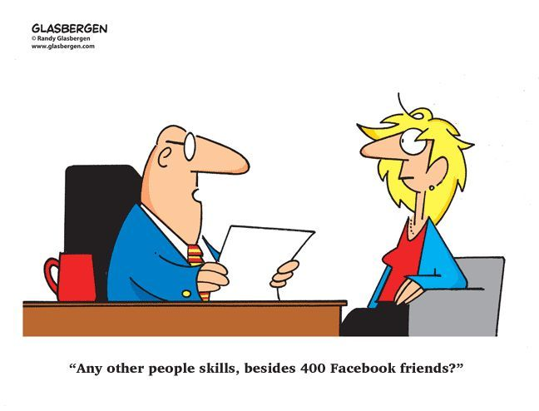

Sales training Level 1 Assessment:

Questions: answer YES OR NO / TRUE OR FALSE

No | Question | True Yes | No False
1 | Your customer is NOT your friend.
2 | F.A.B stands for Features Addon’s and Benefits.
3 | Stock is only the BM’s responsibility.
4 | Is Industry knowledge important?
5 | Is Product knowledge important?
6 | Is it important to establish a relationship with a customer?
7 | Are features the characteristic of the product?
8 | 68% of customers quit because of an attitude of indifference towards the customer by the staff.
9 | 70% of complaining customers will do business with you again if you resolve the complaint in their favour.
10 | Customer service can be summed up as: I care and I can do.

After completing the above go with a positive ATTITUDE and SELL SELL SELL.
Use the techniques you have just learned and see what works for you and what doesn’t.
Remember to give your FM detailed feedback of your experiences and suggestions.

THANK YOU!!

